Use-Case Realization Report
Add Lesson

Issue <1.0>
Revision History
Date | Issue | Description | Author
<dd/mmm/yy> | <x.x> | <details> | <name>

Table of Contents
1. Brief Description 4
2. Flow of Events 4
2.1 Standard Flow 4
2.2 Exception Flow 4
3. Interaction Diagrams 5
3.1 Collaboration Diagram for Add Lesson 5
4. Participating Objects 5
5. Class Diagrams 6
5.1 Class Diagram for Add Lesson 6
6. Derived Requirements 6

Use-Case Realization Report
Add Lesson

Brief Description

Flow of Events

Standard Flow
- Portal Admin log into the system, and go to Lesson Admin Page.
- By clicking the “Add Lesson” button, the JMD module will be called, and the Lesson Page will be displayed.
- Before adding the lesson into database, system will validate the lesson, e.g., whether the lesson to be added already exists in the database.
- JMD module will then process adding the lesson.
- The lesson and the section information will then be stored in Lesson Module, for later reference
- A message says “Lesson has been successfully added.” will be displayed.
- Portal Admin can click the “Logout” button to logout from the system.

Exception Flow
- If the lesson to be added is invalid, an error message will be displayed, and the transaction will be terminated.

Interaction Diagrams

Collaboration Diagram for Add Lesson
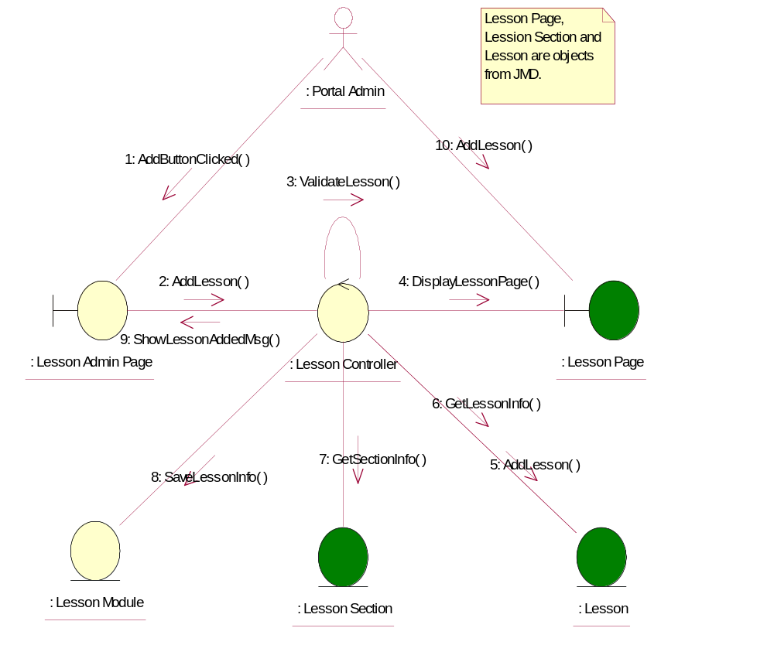

Participating Objects
: Lesson
This entity is the lesson object, it belongs to JMD.
: Lesson Admin Page
This is the page for adding, deleting, modifying lessons.
: Lesson Controller
This is the controller to upload, add, delete and modify lessons.
: Lesson Module
This is the object containing the lesson info.
: Lesson Page
Lesson Page is the one from JMD, which in charge of creating lessons.
: Lesson Section
This entity is the Section object, it belongs to JMD.
: Portal Admin
This is the super user of the system.

Class Diagrams

Class Diagram for Add Lesson
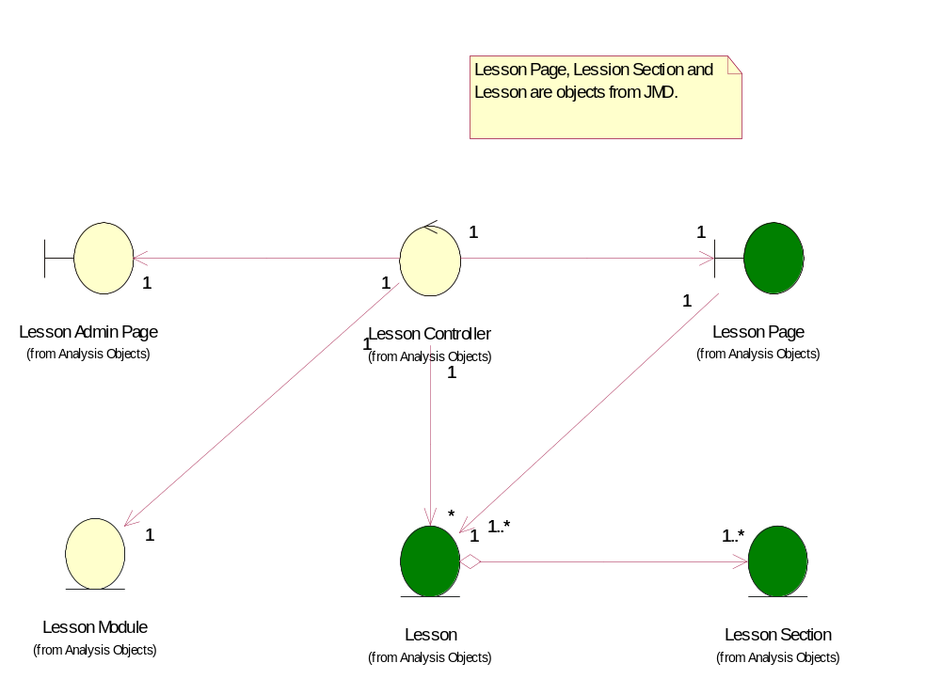

Derived Requirements
[enter the derived requirements here]

